Name: Click or tap here to enter text.
Class: Click or tap here to enter text.
Introduction
National Apprenticeship Week is a fantastic opportunity for you to learn more about apprenticeships and how they might be an exciting option for you when you leave school or college. Following the instructions of your teacher, work your way through this activity pack to begin exploring what apprenticeships are, which apprenticeships are available and to hear from current apprentices who share their inspirational stories.
Please note that some tasks will require access to a computer and the internet.
Social media: @Apprenticeships Hashtag: #NAW2022
_____________________________________________________________________________
Contents
Activity sheet 1: What are apprenticeships? 3
Activity sheet 2: Discover apprenticeships 4
Activity sheet 3: Apprentices in Action 6
Activity sheet 4: Mind the gap 8
Activity sheet 5: Meet apprentice employers 9
Activity sheet 6: The Big Assembly 10
Activity sheet 7: Linking your subjects to apprenticeships 11
Activity sheet 8: Ask an apprentice or employer 13
Activity sheet 9: ‘Build the Future’ 14
Activity sheet 10: Apprenticeship crossword 15
Top tips for exploring apprenticeships
To continue learning about apprenticeships and the exciting
careers available, visit: www.apprenticeships.gov.uk
The government has a fantastic website where you can learn
more about the range of apprenticeships available, how to
search and apply for apprenticeships, what roles are available
by interest area and more. You can also hear real stories from
apprentices about their experiences.
Click the link above or scan the QR code to visit now.

TASK 1: What are apprenticeships?
To complete this task, please follow the below instructions:
- Go to www.apprenticeships.gov.uk/apprentices/becoming-apprentice
- Using the information on the website, answer the questions below to see how much you know about apprenticeships.
- If you are completing this online, please tick the box to indicate your answer.

Q1.
What is an apprenticeship?
☐ A. A study scheme where you go to work
once a week
☐ B. A real job where you learn at the same
time
Q2.
As an apprentice, do you have a specific job?
☐ A. Yes, you have a specific job role
☐ B. No, you try out different work experience
Q3.
Can I still get a degree whilst doing an apprenticeship?
☐ A. No, apprenticeships cannot lead to a
degree
☐ B. Yes, degree apprenticeships allow you to
work and study for a degree at the same
time
Q4.
Will I get paid in an apprenticeship?
☐ A. No, apprenticeships are unpaid
☐ B. Yes, you will get paid a salary
Q5.
Where would I study if I were an apprentice?
☐ A. At school
☐ B. At a college, university, or a training provider
Q6.
How long does an apprenticeship take?
☐ A. 3 - 4 years
☐ B. It can take up to 6 years depending on
the role and apprenticeship level
Q7.
Do apprentices have to pay for their apprenticeship?
☐ A. Yes, they have to pay 10% towards their
study
☐ B. No, the apprenticeship will be paid for by
the employer and the government
Q8.
What age can apprentices be?
☐ A. 16 or over
☐ B. Between 16 – 24

TASK 2: Discover apprenticeships
To complete this task, please follow the below instructions:
- Take a look at the pictures below to see if you can match the apprentice to their job role
- Use the spaces under each photograph to write in the correct apprenticeship job role from the word bank on the next page
- If you are completing this online, please click on the text box to start typing

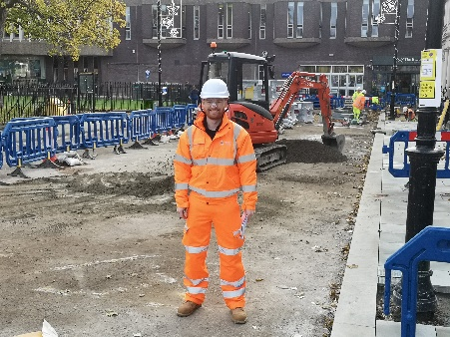 | 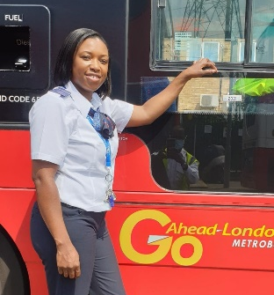
Click or tap here to enter text. | Click or tap here to enter text.
Click or tap here to enter text. | Click or tap here to enter text.
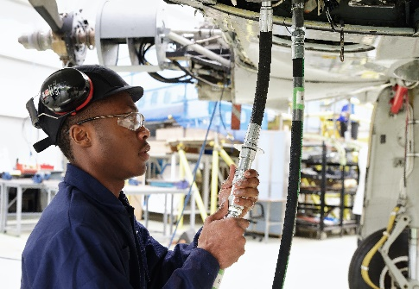 | 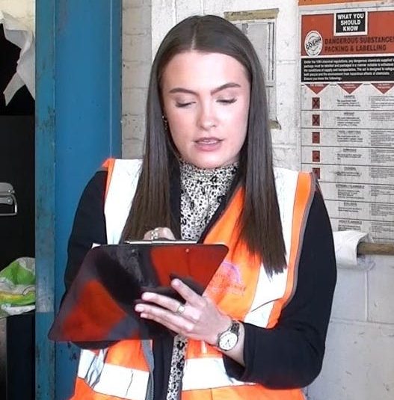
Click or tap here to enter text. | Click or tap here to enter text.

Word Bank
Safety, Health and Environment Technician | Bus Driver  Apprentice | Estimator  Apprentice
HR Apprentice | Aircraft Maintenance Technician | Quality Control Laboratory Technician

Did any of the roles surprise you? Write your notes below …
Click or tap here to enter text.

TASK 3: Apprentices in Action
To complete this task, please follow the below instructions:
- Click on the film below or go to https://appawards.co.uk/aotf/
- Watch the Great Ormond Street Hospital ‘Apprentices in Action’ film and then answer the questions below
- If you are completing this online, please click on the text box to start typing

Why does Sophie feel it is beneficial to be an apprentice?
Click or tap here to enter text.

What does Laurence think apprentices bring to the team?
Click or tap here to enter text.

What benefits does Claire give for doing an apprenticeship?
Click or tap here to enter text.

What was the best part about Zahra’s apprenticeship?
Click or tap here to enter text.

What was Farzin’s advice for future apprentices?
Click or tap here to enter text.

TASK 4: Mind the gap
To complete this task, please follow the below instructions:
- Hayley is an apprentice with Princess Yachts and has volunteered to share her inspiring story with you
- Read Hayley’s article below and see if you can match up the correct words from the word bank into her story
- If you are completing this online, please click on the text box to start typing

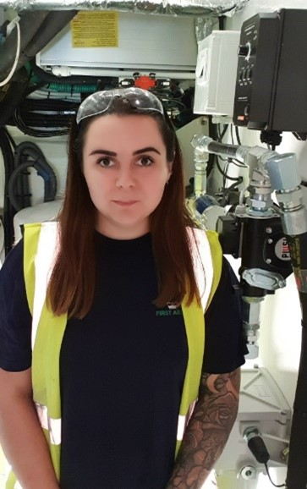
I chose the apprenticeship route as I had already spent a year at college studying engineering and I decided that Click or tap here to enter text. was not for me. I found that apprenticeships worked best for my style of learning. I’ve never been very good at exams so learning on the job and getting the chance to be hands on, whilst gaining skills, experience and Click or tap here to enter text. money meant that an apprenticeship was the best route for me.
I am currently a grade 7 engineer, section lead, and I am also a first aider with Princess Yachts. My day-to day tasks are really Click or tap here to enter text., but can include meetings with my team and assisting them with any queries that they may have and building the yachts’ engine room, which includes installing and Click or tap here to enter text. the engines. I am also first aid trained and trained in mental health first aid so must make sure that I am available should there be any issues.
I never thought that I would be working on the building of the new X95 Princess Yacht. It was my first time working on a Click or tap here to enter text. boat and having the opportunity to work on a project that is completely new to the company was incredibly exciting.
I am so proud of myself for finishing my level 3 apprenticeship in Marine Engineering. After this, I got the Click or tap here to enter text. to take part in the Queens Silver Medal Award. I was also proud to be accepted to continue my learning and do a level 4 apprenticeship, including an HNC. I’m really Click or tap here to enter text. of the progress I’ve made since starting my career.
My Click or tap here to enter text. to you is to not put anything off, take every opportunity you get and try something different. Be open to new ideas and have the drive to succeed.
Word bank
advice | proud | opportunity | varied
testing | earning | University | development
TASK 5: Meet apprentice employers
There are hundreds of employers who offer apprenticeships in England, from a range of sectors and of all sizes. This activity brings you the profiles of different apprenticeship employers that you may or may not have heard of before.
To complete this task, please follow the below instructions:
- Visit https://www.apprenticeships.gov.uk/apprentices/employer-profiles
- Read the 9 employer profiles to learn more about what the employers do
- Click away from the website, set a timer to 1 minute and see how many employers you can remember by matching them up to their descriptions below
- If you are completing this online, please move the images next to the correct description or draw a line to connect them

Designs and provides water, waste, and energy management solutions

Leading supplier of materials and equipment to the building, construction and home improvement industry
TASK 6: The Big Assembly
Provide smart, technology-enabled advice to the property development industry
Provides Cloud IT services to the UK legal and accounting sectors
To complete this task, please follow the below instructions:
- This activity will need to be completed after 12pm on Tuesday 8th February
- Go to www.workpays.co.uk/bigassembly/ and watch the Big Assembly 2022
- Read the questions below and use the space to make a note of your answers
- If you are completing this online, please click on the box and start typing

What was the most interesting fact you learned about apprenticeships?
Click or tap here to enter text.

Which employer did you enjoy hearing from most?
Click or tap here to enter text.

Did any of the points discussed about apprenticeships surprise you? List these below…
Click or tap here to enter text.

TASK 7: Linking your subjects to apprenticeships
Part 1 - To complete this task, please follow the below instructions:
- There are many different apprenticeships that will link to the subjects you enjoy
- Using the apprenticeships word bank on the next page, try to match the apprenticeships that link to the subjects in the table below
- If you are completing this online, click on the text box to start typing

Subject | Apprenticeship
Business Studies | - Click or tap here to enter text.  - Click or tap here to enter text.
Drama and Music | - Click or tap here to enter text.  - Click or tap here to enter text.
English | - Click or tap here to enter text.  - Click or tap here to enter text.
Maths | - Click or tap here to enter text.  - Click or tap here to enter text.
ICT | - Click or tap here to enter text.  - Click or tap here to enter text.
Food Technology | - Click or tap here to enter text.  - Click or tap here to enter text.
Languages | - Click or tap here to enter text.  - Click or tap here to enter text.
PE | - Click or tap here to enter text.  - Click or tap here to enter text.
Art and Design | - Click or tap here to enter text.  - Click or tap here to enter text.

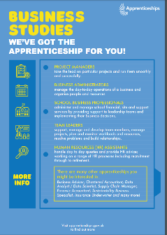
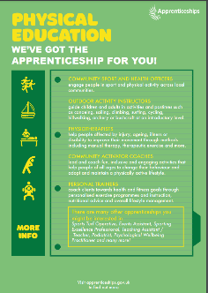
Hints: You can find helpful posters with ideas and clues by clicking this link or scanning the QR code below: www.apprenticeships.gov.uk/influencers/subject-snapshots

Apprenticeships word bank
Product Design Engineer | Aerospace Engineer
Cabin Crew | Live Event Rigger
Junior 2D Artist | Software Developer
Cyber Security Technologist | Project Manager
Human Resources (HR) Assistant | Food and Drink Engineer
Chef de Partie | Junior Journalist
Professional Economist | Transport Planner
Creative Venue Technician | Physiotherapist
Personal Trainer | Public Relations (PR) Assistant
Part 2 - To complete this task, please follow the below instructions:
- Answer the questions below reflecting on the subjects you enjoy and the different apprenticeships that might have interested you
- If you are completing this online, click on the text box to start typing

Did any of the apprenticeships surprise you?
Click or tap here to enter text.

Do you think any of the apprenticeships link to more than one subject?
Click or tap here to enter text.

Did any of the apprenticeships interest you?
Click or tap here to enter text.

TASK 8: Ask an apprentice or employer
To complete this task, please follow the below instructions:
- National Apprenticeship Week is a good opportunity to engage with employers and apprentices to find out more about apprenticeships
- Try to think of some useful questions that you could ask an apprentice or an employer at an event or on social media to find out more about their apprenticeship(s)
- We have given some example questions below to get you started
- If you are completing this online, click on the text box to start typing

Questions for employers
1. What apprenticeships do you offer?
2. Why do you offer apprenticeships?
3. What are you looking for when people apply for your apprenticeships?
4. Click or tap here to enter text.
5. Click or tap here to enter text.
6. Click or tap here to enter text.
7. Click or tap here to enter text.
8. Click or tap here to enter text.
9. Click or tap here to enter text.
10. Click or tap here to enter text.

Questions for apprentices
1. What made you choose an apprenticeship?
2. What do you do in your day-to-day?
3. What is the best part about your apprenticeship?
4. Click or tap here to enter text.
5. Click or tap here to enter text.
6. Click or tap here to enter text.
7. Click or tap here to enter text.
8. Click or tap here to enter text.
9. Click or tap here to enter text.
10. Click or tap here to enter text.

Submit your questions on Twitter over National Apprenticeship Week using #AskAnApprentice
for apprentice questions or #AskAnEmployer for employer questions
TASK 9: ‘Build the Future’
To complete this task, please follow the below instructions:
- Let’s get creative!
- Create a poster that you could use at school to celebrate National Apprenticeship Week
- Use the space below to jot down ideas of what you could include to inspire your friends and teachers
- We’ve included some questions that may give you some ideas – plus a colourful poster to help you to think about the design too
- If you are completing this online, please click on the text box to start typing

What could I put on my poster?

- What have you learnt about apprenticeships so far?
- Has anything surprised you?
- Have you looked beyond the roles you thought some of the apprentices in the pack might do and discovered them to have unexpected jobs?
- Have you looked beyond full-time University being the only way to achieve certain jobs?
- Have you looked beyond which employers you thought might offer apprenticeships?
- Have you looked beyond the idea that apprenticeships might only be for certain types of people?

My ideas
Click or tap here to enter text.

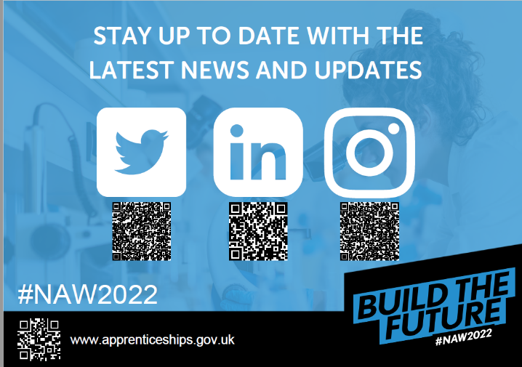
Don’t forget….

To send your posters to us! We would love to see the exciting things that you have created. Ask your teacher to take a snap and tag us on social media!

@Apprenticeships

#BuildTheFuture

TASK 10: Apprenticeship crossword

To complete this task, please follow the below instructions:
- Test your knowledge of apprenticeships by completing the crossword below
- Using the clues provided, add the answer into the correct place in the crossword
- If you are completing this online, click in the correct box to start typing

 |  |  |  |  |  |  | 1
 |  |  |  |  | 2
 |  |  | 3
 |  |  | 4 |  |  |  |  |  |  |  |  | 5
 |  | 6
 |  |  | 7
 | 8
 |  |  | 9
 | 10

Across | Down
2. In an apprenticeship, you work and …… at  the same time  4. Moving up through the organisation  6. You receive the same as any other employee  7. Your employer and provider will give you this  to help you to learn how to do your role  8. An area where industries and businesses  share the same related activities or subject  area  9. Apprentices get paid this  10. The organisation that you work for | 1.The theme for National Apprenticeship Week  this year is ‘Build the …….?’  3. A real job where you learn and earn at the  same time  5. You spend 20% of your time in an apprenticeship

